"LET'S HAVE A CATCH"

A Checklist of Basic Throwing and Catching Fundamentals for your Little League Player

THROWING

____ GRIP

Kids should learn to grip the ball across the seams (Four Seam Grip). Kids should also learn to grip the ball with their fingers and not with their entire hand. Young children or children with small hands can use three fingers on top of the ball, instead of two fingers.

____ BEAR CLAW

Before throwing the ball, kids should learn to point the ball directly behind them (as if a pitcher is showing the ball to second base). This prevents kids from pushing the ball towards their target and teaches them to use their wrist as they throw.

____ POINT FRONT SHOULDER AT TARGET

Kids should learn to throw with their upper body turned and their front shoulder (not their chest) facing the target.

____ STEP TOWARDS TARGET

Kids should be encouraged to step towards their target and not to the side.

____ CONSISTENT "OVER-THE-TOP" ARM ANGLE

Kids should be discouraged from throwing "sidearm" and encouraged to get on top of the ball consistently.

____ BALANCE

Kids should be encouraged to stay balanced throughout their throwing motion.

____ "TRUST YOUR ARM"

Many young kids struggle to learn proper mechanics because they want to fall back on bad habits with which they are comfortable, especially after a few bad throws. Kids should be encouraged to trust their arms and not worry about a few errant throws.

_____ FOOTWORK

Almost every catch and throw combination requires footwork as kids should be catching the ball faced up to their partner (feet pointed toward their partner) and throwing the ball with the side of their feet pointed towards their partner.
Example of a four seam grip:

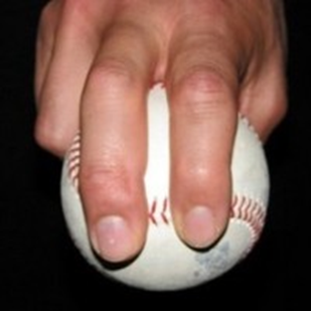

CATCHING

_____ CENTER THE CATCH

Kids should be strongly encouraged to move their feet and get in front of every throw. Play catch with soft youth baseballs if your kid is struggling to center up the catch due to being afraid of the ball.

_____ CATCH WITH TWO HANDS

Kids should be taught to catch with two hands, which eventually enables a much quicker transfer from catch to throw.

MISCELLANEOUS

_____ JUST THROW

Although we want to teach kids proper mechanics, we don't necessarily want them thinking about their mechanics while they are throwing. Try to keep things simple and try not to emphasize more than one or two fundamentals at a time. Sometimes it is better to say "Just Throw".

_____ HAVE FUN

The key to good throwing is repetition. The key to getting enough repetition is getting the kids to the point that they want to play catch as much as possible. That will only happen if the kids have fun when they play catch.

_____ EMPHASIZE THE POSITIVE

Don't fall into the trap of providing consistently negative feedback while playing catch ("That was poor balance"--"This was poor footwork"--"Stop throwing sidearm", etc). If you give a lot of positive feedback, the kids will listen closer to your constructive criticism.
Prepared by the Memorial Skills Program/DCM

